**HOSTEL MANAGEMENT SYSTEM**

A Mini Project Report Submitted by

**SWARAJ YJ (4NM16CS160)**

**TERRIL JOEL NAZARETH (4NM16CS162)**

UNDER THE GUIDANCE OF

**Mr. Ramesha Shettigar**

Assistant Professor

Department of Computer Science and Engineering

in partial fulfillment of the requirements for the award of the Degree of

Bachelor of Engineering in

Computer Science & Engineering

from

Visvesvaraya Technological University, Belagavi



DEPARTMENT OF COMPUTER SCIENCE AND ENGINEERING

N.M.A.M. INSTITUTE OF TECHNOLOGY

(An Autonomous Institution under VTU, Belagavi) (AICTE approved, NBA Accredited, ISO

9001:2008 Certified) NITTE -574 110, Udupi District, KARNATAKA.

**April 2019**



(ISO 9001:2015 Certified), Accredited with ‘A’ Grade by NAAC

   : 08258 - 281039 – 281263, Fax: 08258 – 281265

**Department of Computer Science and Engineering**

B.E. CSE Program Accredited by NBA, New Delhi from 1-7-2018 to 30-6-2021

**DEPARTMENT OF COMPUTER SCIENCE AND ENGINEERING**

CERTIFICATE

“Hostel Management System”

is a bonafide work carried out by

Swaraj YJ(4NM16CS160) Terril Joel Nazareth(4NM16CS162)

in partial fulfillment of the requirements for the award of Bachelor of Engineering Degree in Computer Science and Engineering prescribed by Visvesvaraya Technological University, Belagavi during the year 2018-2019.

It is certified that all corrections/suggestions indicated for Internal Assessment

have been incorporated in the report.

The Mini project report has been approved as it satisfies the academic requirements in respect of the project work prescribed for the Bachelor of

Engineering Degree.

Signature of Guide Signature of HOD

# **ACKNOWLEDGEMENT**

We believe that our project will be complete only after we thank the people who have contributed to make this project successful.

First and foremost, we express our deep sense of gratitude and indebtedness to our guide **Mr. Ramesha Shettigar**, Assistant Professor, Department of Computer Science and Engineering, for his inspiring guidance, constant encouragement, support and suggestions for improvement during the course of our project.

We sincerely thank **Dr. K.R. Udaya Kumar Reddy**, Head of Department of Computer Science and Engineering, Nitte Mahalinga Adyantaya Memorial Institute of Technology, Nitte.

our sincere thanks to our beloved principal, **Dr. Niranjan N. Chiplunkar** for giving us an opportunity to carry out our project work at our college and providing us with all the needed facilities.

We also thank all those who have supported us throughout the entire duration of our project.

Finally, we thank the staff members of the Department of Computer Science and Engineering and all our friends for their honest opinions and suggestions throughout the course of our project.

Swaraj YJ(4NM16CS160)

Terril Joel Nazareth (4NM16CS162)

**ABSTRACT**

For a past few years the number of educational institutions are increasing rapidly. There by the number of hostels are also increasing for the accommodation of the students studying in this institution. And hence there is lot of strain on the person who are running the hostel and software are not usually used in this context. This particular project deals with the problem on managing a hostel and avoids the problem which occur when carried out manually.

To provide a platform where information can be communicated to the user of the app regarding the activities that would come under the institute or even under the hostel. The meal schedule can be viewed by the user to have an understanding of the dishes that would be available. In the case of absence from the hostel on particular day “Movement register” can be used log that information. If a replacement is required or damage is incurred to the utilities in any person’s room this can brought to notice by the entry of the same into a “Maintenance register” that has been allocated for this purpose. It also has contact information of hostel in charge.

Identification of the drawbacks of the existing system leads to the designing of computerized system that will be compatible to the existing system with the system, which is more user friendly and more GUI oriented. We can improve the efficiency of the system, thus overcome the drawbacks of the existing system.

**Hostel Management System**

**Table Of Contents:**

**Title Page no.**

1. **INTRODUCTION 1**
2. **LITERATURE SURVEY 2**
3. **SYSTEM REQUIREMENT AND SPECIFICATION 3-4**
4. **SYSTEM DESIGN 5-8**
5. **IMPLEMENTATION 9-14**
6. **SYSTEM TESTING 15-16**
7. **SCREENSHOTS 17-21**
8. **CONCLUSION AND FUTURE WORK 22**

**CHAPTER 1**

**INTRODUCTION**

* 1. **Scope**

Hostel management system is a flexible, easy to use, cost effective, secure and customizable Web- based tool designed to deliver conceivable benefit to fleet hostellers. It is used to digitize the circular systems, maintenance register, movement register and mess time table all in one single android mobile phone and manage them efficiently.

**1.2 Importance**

In a large hostel it is very difficult to keep track of all the information regarding students. With the help of hostel management system, the data is stored in the digitized form and hence reduces the paper work. The hostel management system makes use of one lone centralized database running from a central server. The data can be efficiently stored and retrieved which makes the application sophisticated and user friendly. The application is implemented on android platform which is linked to the Google firebase as a server for access of data.

**1.3 Objective:**

The objective of this project is a mobile application developed for managing various activities in the hostel. Identification of the drawbacks of the existing systems leads to the designing of computerized system that will be compatible to the existing system with the system which is more user friendly and more GUI oriented. We can improve the efficiency of the system, thus overcome the drawbacks of the existing system.

**CHAPTER 2**

**LITERATURE SURVEY**

**2.1 Technical Background:**

In Hostel Management System the information regarding mess timetable, circulars, movement registers and maintenance register are stored in the backend i.e., in Google Firebase Database. GUI of the application enables to access and modify data efficiently.

**2.2 Existing system:**

* In the hostel important circulars are put up on the notice board which doesn’t guarantee that all the student will be aware of this.
* For the movement register student have to fill up record book manually.
* For the maintenance register student have to fill up the register manually in the book.
* Every student may not have contact numbers of warden, electrician and office.
* Mess timetable is made available only on the notice board

**2.3 Proposed system**

In this Hostel Management Application all the existing traditional system can be digitized and can be made available at the tip of the finger. All the above existing system is upgraded and manual work can be reduced for the record management. There will be one administrator who will manage the data at the back end.

* Circulars will be made available online through mobile application.
* Students can fill up and can modify movement registers anytime, anywhere through a mobile application.
* Maintenance registers made available online through mobile application.
* Contact numbers of concerned people of the hostel is made available in the application.
* And Mess time table can be viewed through an mobile application

**CHAPTER 3**

**SYSTEM REQUIREMENT AND SPECIFICATION**

**3.1 Introduction**

Requirements are during early stages of a system development as a specification of what should be implemented or as a constraint of some kind of on the system. They may be: a

user level facility description, a detailed specification of expected system behavior, a general system property, a specific constraint on the system, and information on how to carry out

some computation or a constraint on the development of the system. The end product of the requirement analysis phase is a requirement specification. The requirement specification is a reconstruction of the result of this analysis phase. Its purpose is to communicate this result to others. System requirements are more detailed descriptions of the user requirements. They may serve as the basis for a contract to the implementation of the system and should therefore be a complete and consistent specification of the whole system. They are used by software engineers as the starting point of system design. In principle, the system requirements should state what the system should do and not how it should be implemented. However, at the level of detail required to specify the system completely, it is virtually impossible to exclude all design information.

Natural language is often used to write system requirements specifications. Further

problems with natural language can arise when it is used for more detailed specification:

1. Natural language understanding relies on the specification of the readers and writers

using the same words for the same concept. This leads to misunderstandings

because of the ambiguity of the natural language.

2. A natural language requirements specification is over-flexible. You can say the same

thing in completely different ways. It is up to the reader to find out when requirements

are same and when they are distinct.

3. There is no easy way to modularize natural language requirements. It may be difficult

to find all the related requirements. To discover the consequence of a change, you

may have to look at every requirement rather than just a group of related

requirements.

**3.2 Functional Requirements**

The functional requirements are the statement of services the system should provide, how

system reacts to particular inputs and how system should behave in particular situation. It

describes the functionality that the system provides.

Our app requires:

I) Active internet connection.

II) A firebase console to store the data

**3.3 User Requirements**

The user requires active internet connection to use the app.

**3.4 Software Requirements**

I. Operating System: Windows 7/8/10 (32-bit or 64-bit)

II. Android SDK

III. Android Studio

IV. Firebase account.

**3.4.1 Android SDK**

I. The Android SDK provides you the API libraries and developer tools necessary to build,

test, and debug apps for Android. The ADT bundle includes the essential Android SDK

components and a version of the Eclipse IDE with built-in Android Developer Tools to

streamline the Android app development. ADT bundle consists of following components for developing the application

II. Eclipse + ADT plugin.

III. Android SDK Tools

IV. Android Platform-tools

V. The latest Android platform

VI. The latest Android system image for the emulator

**3.4.2 Android Studio**

**Android Studio** is the official integrated development environment (IDE) for Google's Android operating system, built on JetBrains' IntelliJ IDEA software and designed specifically for Android development. It is available for download on Windows, macOS and Linux based operating systems. It is a replacement for the Eclipse Android Development Tools (ADT) as the primary IDE for native Android application development.

Android Studio was announced on May 16, 2013 at the Google I/O conference. It was in early access preview stage starting from version 0.1 in May 2013, then entered beta stage starting from version 0.8 which was released in June 2014. The first stable build was released in December 2014, starting from version 1.0. The current stable version is 3.3, which was released in January 2019.

**3.4.3 Firebase**

**Firebase** is a mobile and web application development platform developed by Firebase, Inc. in 2011, then acquired by Google in 2014.As of October 2018, the Firebase platform has 18 products, which are used by 1.5 million apps. Firebase provides a real-time database and backend as a service. The service provides application developers an API that allows application data to be synchronized across clients and stored on Firebase's cloud. Firebase Storage provides secure file uploads and downloads for Firebase apps, regardless of network quality. The developer can use it to store images, audio, video, or other user-generated content. Firebase Storage is backed by Google Cloud Storage.

**3.5 HARDWARE REQUIREMENTS**

I. Intel Pentium Core 2 Duo processor.

II. Minimum 3 GB RAM (8GB recommended).

III. 2GB free disk space

IV. USB 2.0 or higher.

V. Android enabled devices required in the client side.

**CHAPTER 4**

**SYSTEM DESIGN**

**4.1 Use case model for Hostel Management**

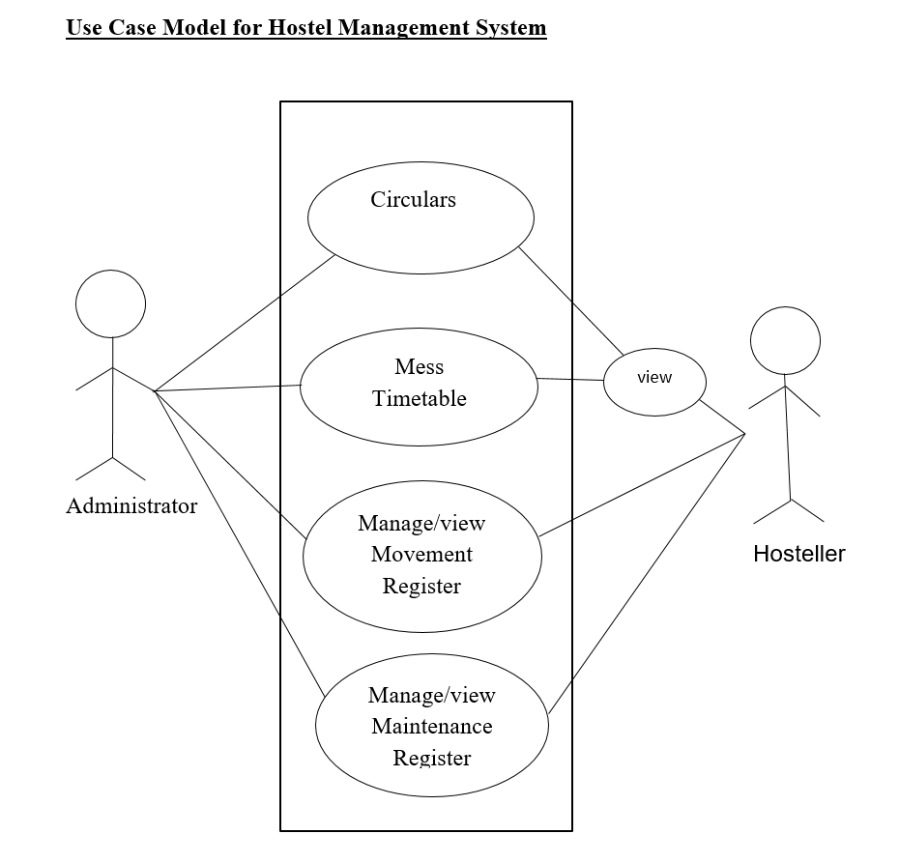

**4.2 Sequence diagram for Hostel Management System**

Application

Administrator

User

Upload Circulars

Upload Mess Timetable

Login

Login Successful

Insert/Update/Delete Register

Manage/View Register

**4.3 Data Flow Diagram**

Launch application

Login

Main Page

Circulars

Mess

Timetable

Firebase

Database

yes

Valid

No

Maintenance and Movement Register

1. The administrator logs into google firebase account, uploads circulars, mess timetables and manages movement registers and maintenance register
2. The user at the front end will be able to view circulars, timetables and can insert update delete the movement and maintenance registers.
3. Each user is given with a unique username and password.

**4.4 Database Design**

The database is designed using Google Firebase Console in which data is stored in popular data structure known as JSON tree (JavaScript Object Notation). Every time when the data transfer happens from client end, the information given to the UI is converted into JSON tree structure which is efficient and faster way to retrieve and store data.

**A snapshot of the data of circular list in a firebase**

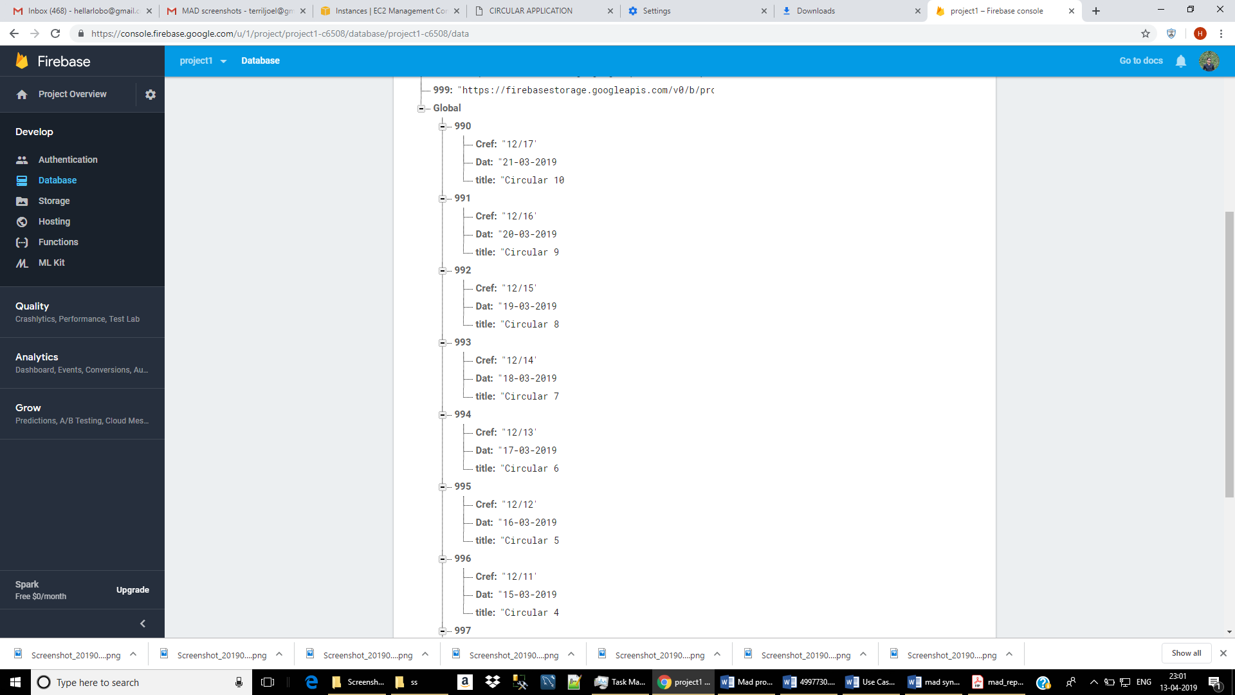

**CHAPTER 5**

**IMPLEMENTATION**

We are here designing hostel Management system to automate and manage all the activities of the hostel. We are designing circular management system so that user remain update with all the events occurring in hostel. Movement register form is also provided if student wants to move out of hostel. Maintenance register keep track of any damage to the utilities. It also provides the information about the mess time table.

**5.1 SOLUTION APPROACH/METHODOLOGY**

We are here using xml and java for the front end and firebase for the backend as a server.

**5.1.1 Firebase**

developers‟ builds high-quality apps. It stores the data in

JavaScript Object Notation (JSON) format which doesn‟t use

Firebase is considered as web application platform. It helps query for inserting, updating, deleting or adding data to it. It is the backend of a system that is used as a database for storing data

Firebase real-time database feature is very easy to use. Once the Firebase and database dependency is added to the app, unstructured data can be added to database by the following

code [7]:

//Write a message to the database

FirebaseDatabase database= FirebaseDatabase.getInstance;

DatabaseReference myref=database.getReference(“node”);

myRef.setValue (“Hello, World”);

**5.1.2 Storage**

The files like images, audio, video etc can be stored in the app. The data stored is highly secured and is robust in nature means it resumes from the last point if any network error occurs. The steps below are to be followed to use storage feature in Android application:

• Once the Firebase and storage dependency are

added to the application, create instance of

FirebaseStorage storageobject =FirebaseStorage.getInstance();

• Second, create the reference to location by:

StorageReference FileRef = storageRef.child("filePath");

• The file can be uploaded by using one of putBytes(),

putFile(), putData() or putStream() method which

returns to UploadTask.

**5.1.3 FIREBASE AND ANDROID APP**

An Android application has been developed for the demonstration of Firebase. In this app images along with strings are loaded to Firebase and retrieved from Firebase similar to Instagram. For the development of an Android app to demonstrate the use of Firebase, prototyping model has been followed.

**Steps for connecting App to Firebase:**

Step1: An account in the Firebase Login has to be created at https://www.firebase.com/login/ using the Google account.

Step2. Creating a new application on Firebase. Firebase creates a new application when one logs in for the first time. Also, at the bottom left corner, one can find an option to create a new application on the Firebase server. The app url has to be unique among all applications deployed on Firebase.

Step3. Next step is to add Firebase as a project dependency. Make changes to the following lines to the build.gradle file, which is located in the app‟s project folder, and not the root

folder.

After adding any dependency one has to make sure to sync the

application.

If there is any build error complaint about duplicate files then one can choose to exclude those files by adding the packaging Options directive to the build.gradle file:

android

Step4. Next, add permissions to Android application, Add network

permission to the app, the same way it has been done for parse

earlier. Now add the following line to the

AndroidManifest.xml file:

<uses-permission android:name="android.permission.INTERNET" />

Password

E-mail

User

Description

Title

Image URL

Post

(root)

Firebase is a Backend-as-a-Service — BaaS — that started as a [YC11 startup](http://blog.ycombinator.com/firebase-yc-s11-raises-5-dollars-dot-6m-series-a-from-union-square-ventures-and-flybridge) and grew up into a next-generation app-development platform on Google Cloud Platform.

**It’s a Realtime Database**

Real-time data is the way of the future. Nothing compares to it. Most databases require you to make HTTP calls to get and sync your data. Most databases give you data only when you ask for it.When you connect your app to Firebase, you’re not connecting through normal HTTP. You’re connecting through a WebSocket. WebSockets are [much, much faster than HTTP](http://www.websocket.org/quantum.html). You don’t have to make individual WebSocket calls, because one socket connection is plenty. All of your data syncs automagically through that single WebSocket as fast as your client’s network can carry it. Firebase sends you new data as soon as it’s updated. When your client saves a change to the data, all connected clients receive the updated data almost instantly.

#### **It’s File Storage**

Firebase Storage provides a simple way to save binary files — most often images, but it could be anything — to Google Cloud Storage **directly from the client!!!**

**5.1.4 Java**

There are a number of ways to create apps for Android devices, but the recommended method for most developers is to write native apps using Java and the Android SDK. Java for Android apps is both similar and quite different from other types of Java applications.

If you have experience with Java (or a similar language) then you’ll probably feel pretty comfortable diving right into the code and learning how to use the Android SDK to make your app run. But if you’re new to programming or object-oriented languages then you’ll probably want to get familiar with the syntax of the Java language and how to accomplish basic programming tasks before learning how to use the Android SDK.

**5.2 IMPLEMENTATION CODE**

**5.2.1 The following code is used to insert data into firebase:**

FirebaseApp.initializeApp(**this**);  
**reff** = FirebaseDatabase.getInstance().getReference(**"Maintenance Register"**);  
**add**.setOnClickListener(**new** View.OnClickListener() {  
 @RequiresApi(api = Build.VERSION_CODES.**N**)  
 @Override  
 **public void** onClick(View v) {  
 String bc = MainPageActivity.b;  
 String i = **issue**.getText().toString().trim();  
 String bn = **blockno**.getText().toString().trim();  
 String rn = **roomno**.getText().toString().trim();  
  
 **if**(i.equalsIgnoreCase(**""**))  
 {  
 **issue**.setError(**"Fields cannot be empty"**);  
 **return** ;  
 }  
 **if**(bn.equalsIgnoreCase(**""**))  
 {  
 **blockno**.setError(**"Fields cannot be empty"**);  
 **return** ;  
 }  
 **if**(rn.equalsIgnoreCase(**""**))  
 {  
 **roomno**.setError(**"Fields cannot be empty"**);  
 **return** ;  
 }  
 **int** intbn=Integer.parseInt(bn);  
 **if**(intbn<=0||intbn>=6)  
 {  
 **blockno**.setError(**"Invalid block number"**);  
 **return**;  
 }  
 **int** intrn=Integer.parseInt(rn);  
 **if**(intrn<=0)  
 {  
 **roomno**.setError(**"Invalid room number"**);  
 **return**;  
 }  
 String date=**new** SimpleDateFormat(**"dd-MM-yyyy"**, Locale.getDefault()).format(**new** Date());  
  
  
 **mrc2**.setDate(date);  
  
 **mrc2**.setBlockno(bn);  
 **mrc2**.setIssue(i);  
 **mrc2**.setRoomno(rn);  
 **mrc2**.setStatus(**"0"**);  
  
 String id = **reff**.push().getKey();  
  
 **reff**.child(bc).child(id).setValue(**mrc2**);  
 Toast.makeText(getApplicationContext(),**"Registered Sucessfully"**,Toast.**LENGTH_LONG**).show();

**5.2.2 The following code is used to update the data in the firebase:**

**reff**=FirebaseDatabase.getInstance().getReference().child(**"Maintenance Register"**);  
 **reff**.addListenerForSingleValueEvent(**new** ValueEventListener() {  
 @RequiresApi(api = Build.VERSION_CODES.**N**)  
 @Override  
 **public void** onDataChange(@NonNull DataSnapshot dataSnapshot) {  
 **if** (dataSnapshot.child(bc).child(id).exists()) {  
 String y = dataSnapshot.child(bc).child(id).child(**"status"**).getValue().toString().trim();  
 **if** (y.equalsIgnoreCase(**"1"**)) {  
 Toast.makeText(getApplicationContext(), **"Updatation not allowed"**, Toast.**LENGTH_LONG**).show();  
 **return**;  
 }  
  
 String i = **e1**.getText().toString().trim();  
 String bn = **e2**.getText().toString().trim();  
 String rn= **e3**.getText().toString().trim();  
  
  
  
 **if**(i.equalsIgnoreCase(**""**))  
 {  
 **e1**.setError(**"Fields cannot be empty"**);  
 **return** ;  
 }  
 **if**(bn.equalsIgnoreCase(**""**))  
 {  
 **e2**.setError(**"Fields cannot be empty"**);  
 **return** ;  
 }  
 **if**(rn.equalsIgnoreCase(**""**))  
 {  
 **e3**.setError(**"Fields cannot be empty"**);  
 **return** ;  
 }  
 **int** intbn=Integer.parseInt(bn);  
 **if**(intbn<=0||intbn>=6)  
 {  
 **e2**.setError(**"Invalid block number"**);  
 **return**;  
 }  
 **int** intrn=Integer.parseInt(rn);  
 **if**(intrn<=0)  
 {  
 **e3**.setError(**"Invalid room number"**);  
 **return**;  
 }  
 String date=**new** SimpleDateFormat(**"dd-MM-yyyy"**, Locale.getDefault()).format(**new** Date());  
  
  
  
 **mrc2**.setIssue(i);  
 **mrc2**.setBlockno(bn);  
 **mrc2**.setRoomno(rn);  
 **mrc2**.setDate(date);  
  
  
 **reff**.child(bc).child(id).setValue(**mrc2**);  
 Toast.makeText(getApplicationContext(), **"Updated Sucessfully"**, Toast.**LENGTH_LONG**).show();  
  
 }  
 }  
 @Override  
 **public void** onCancelled(@NonNull DatabaseError databaseError) {  
  
 }  
 });  
 }  
});

**5.2.3 The following code is used to delete the data in the firebase:**

**reff**=FirebaseDatabase.getInstance().getReference().child(**"Maintenance Register"**);  
**reff**.addListenerForSingleValueEvent(**new** ValueEventListener() {  
 @Override  
 **public void** onDataChange(@NonNull DataSnapshot dataSnapshot) {  
 String y = dataSnapshot.child(bc).child(id).child(**"status"**).getValue().toString().trim();  
 **if** (y.equalsIgnoreCase(**"1"**)) {  
 Toast.makeText(getApplicationContext(), **"Deletion not allowed"**, Toast.**LENGTH_LONG**).show();  
 **return**;  
 }  
 **if** (dataSnapshot.child(bc).child(id).exists()) {  
  
 **reff**.child(bc).child(id).removeValue();  
  
  
 Toast.makeText(getApplicationContext(), **"Deletion successfull"**, Toast.**LENGTH_LONG**).show();  
 finish();  
 }  
 }  
  
 @Override  
 **public void** onCancelled(@NonNull DatabaseError databaseError) {  
  
 }  
});

The following code is used to display the data after fetching from the firebase:

**myreff**= FirebaseDatabase.getInstance().getReference(**"Maintenance Register"**);  
**myreff**.addListenerForSingleValueEvent(**new** ValueEventListener() {  
 @Override  
 **public void** onDataChange(@NonNull DataSnapshot dataSnapshot) {  
 **for**(DataSnapshot ds:dataSnapshot.child(MainPageActivity.b).getChildren())  
 {  
  
 String r = ds.getKey();  
 String s = **"Ref No :"** + ds.getKey() + **"\nIssue :"** + ds.child(**"issue"**).getValue() + **"\nBlock No :"** + ds.child(**"blockno"**).getValue() + **"\nRoom No :"** + ds.child(**"roomno"**).getValue();  
  
 **temp**.add(s);  
 **reffno1**.add(r);  
  
  
 }  
 **int** n= (**int**) dataSnapshot.child(MainPageActivity.b).getChildrenCount();  
 **for**(**int** i=n-1;i>=0;i--)  
 {  
 **list**.add(**temp**.get(i));  
 **reffno2**.add(**reffno1**.get(i));  
 }  
 **listView**.setAdapter(**adapter**);  
 }  
 @Override  
 **public void** onCancelled(@NonNull DatabaseError databaseError) {  
  
 }  
})

**CHAPTER 6**

**SYSTEM TESTING**

**6.1 INTRODUCTION**

System testing of software or hardware is testing conducted on a complete, integrated system to evaluate the system’s compliance with its specified requirement. System testing falls within the scope of black box testing, and as such, requires no knowledge of the inner design of the code or logic.

System testing is usually required before and after a system is put in place. A series of systematic procedures are referred to while testing is being performed. These procedures tell the tester how the system should perform and where common mistakes may be found. Testers usually try to “break the system” by entering data that may cause the system to malfunction or return incorrect information. System testing is performed on the entire system in the context of System Requirement Specification (SRS). System testing is an investigatory testing phase, where the focus is to have almost a destructive attitude and tests not only the design, but also the behaviour and even the believed expectation of the user. It is also intended to test up to and beyond the bound on the Software Requirement Specification The testing phase is performed after the coding to detect all the errors and provide quality assurance and ensure reliability of the software. Testing is vital to the success of the system. During testing, the software to be tested and executed with a set of test cases, and the behaviour of the system for the test cases is evaluated to determine if the system is performing as expected. Clearly, the success of the testing in revealing errors depends critically on the test cases.

The different testing strategies employed in this project are explained in this chapter.

**6.2 UNIT TESTING**

In computer programming, unit testing is a software verification and validation method in which a programmer tests if individual units of source code are fit for use. A unit is a smallest testable part of an application. It is also called as module testing. The goal of unit testing is to isolate each part of the program first and then testing the sum of its parts, integration testing becomes much easier.

In our project, we apply this by testing the various modules of the application and also each feature individually.

**6.3 INTEGRATION TESTING**

Integration testing is thee phase in software testing in which individual software modules are combined and tested as a group. It occurs after unit testing and before system testing. Integration testing takes as its input modules that have been unit tested, groups them in larger aggregates, applies tests defined in an integration test plan to those aggregates, and delivers as its output the integrated system ready for the system testing.

The purpose of the integration testing is to verify functional, performance and reliability requirement placed on major design items. All the different modules of the project are combined and tested.

**Test case for Hostel Management System:**

|  |  |  |  |
| --- | --- | --- | --- |
| Sl.no | TEST CASES | OUTPUT EXPECTED | ACTUAL OUTPUT |
| 1 | Click on ‘Login’ button | When the user clicks on the login button, the username and password is taken form the textbox and sent to server for validation | Same as expected |
| 2 | Click on ‘Circulars’ button | When the user clicks on this button, all the circulars are fetched from the firebase database and displayed in the form of a list. | Same as expected |
| 3 | Click on ‘Mess Timetable’ button | When the user clicks on this button, it shows the dishes served on particular day of week based on the user’s choice. | Same as expected |
| 4 | Click on ‘Add Record’ button | When the user clicks on this button, form is displayed for the entry of record either for Movement Register or Maintenance Register, based on user’s choice. | Same as expected |
| 5 | Click on ‘Display Record’ button | When the user clicks on this button, list of all the existing records of a user is displayed and when particular item is selected, update and delete option is shown. | Same as expected |
| 6 | Click on ‘Contact Info’ button | When the user clicks on this button, list of all officers is shown, which when clicked is redirected to call. | Same as expected |

**CHAPTER 7**

**SCREENSHOTS**

**I. First Loading page II. Login Page**

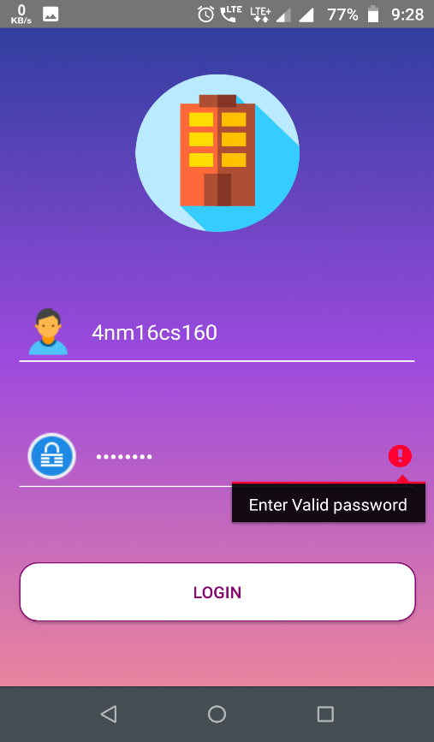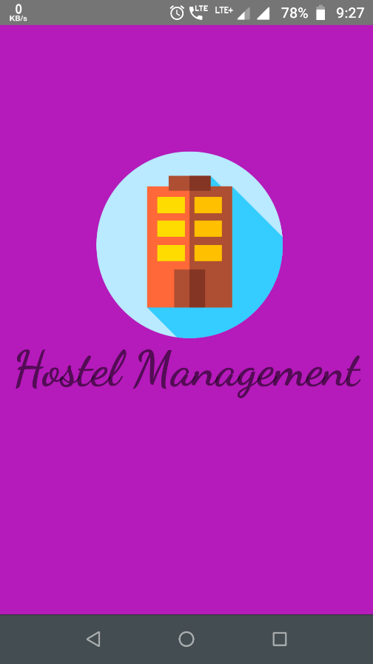

**III.Main Page**

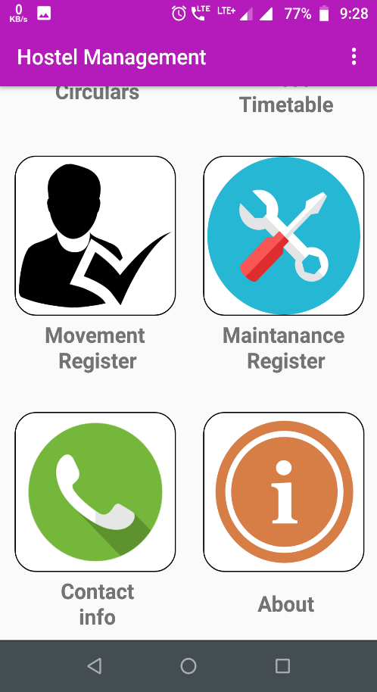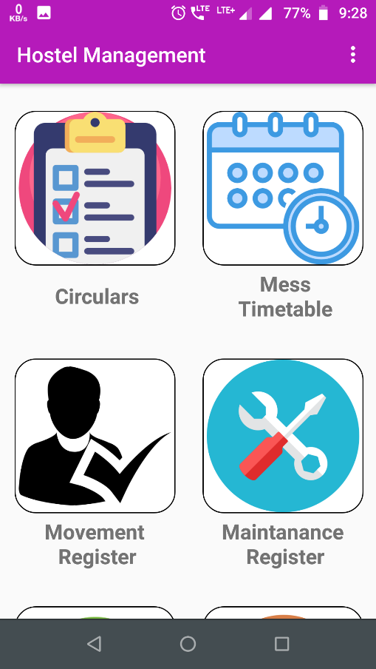

**IV. Circular Recycler view V. Circular PDF view**

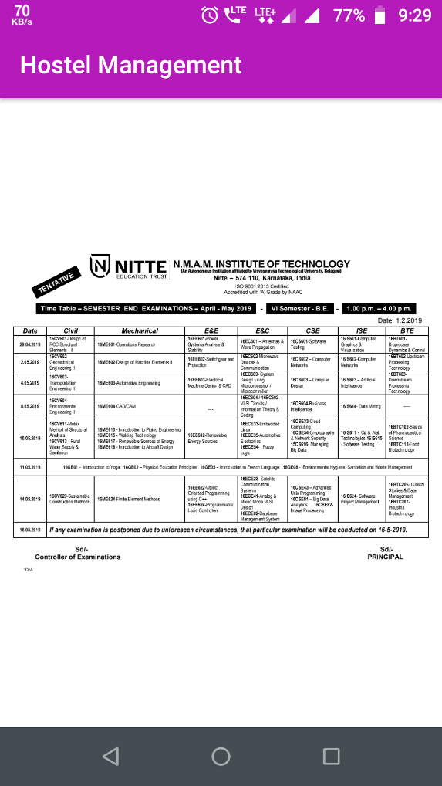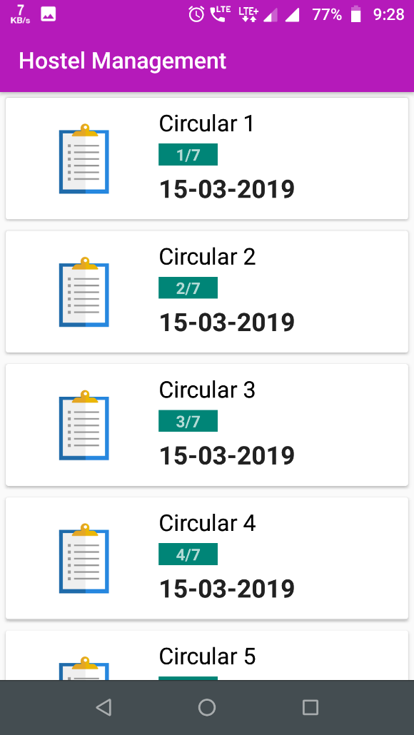

**VI. Mess Timetable**

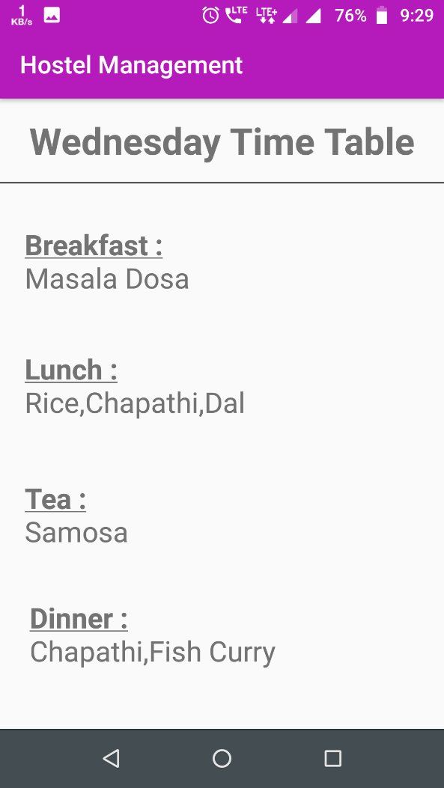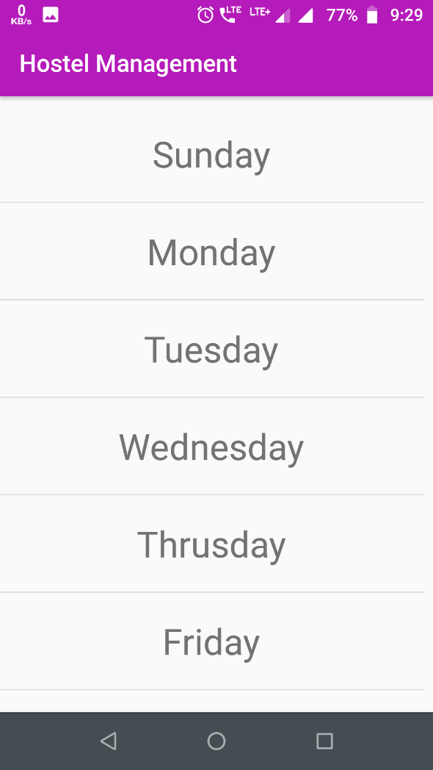

**VII. Movement Register**

**i. Options with the register ii. Add register form**

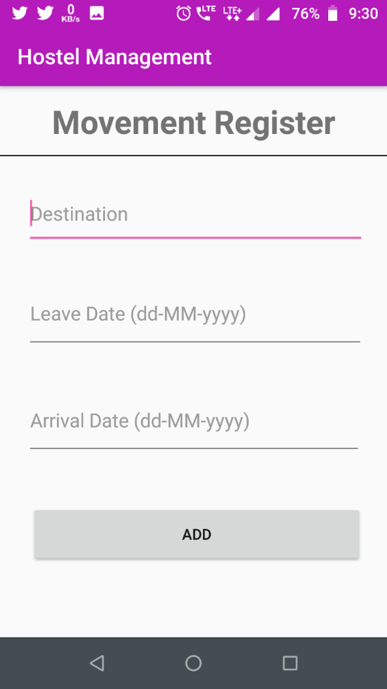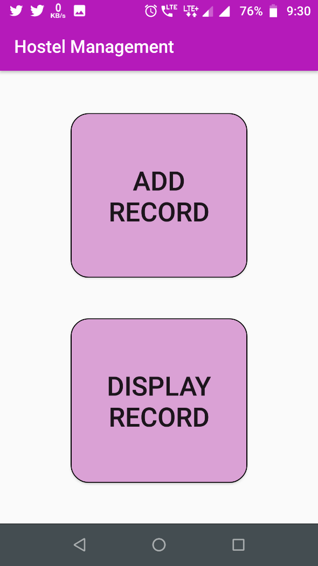

**iii. List of registers added iv. Update form with a delete button**

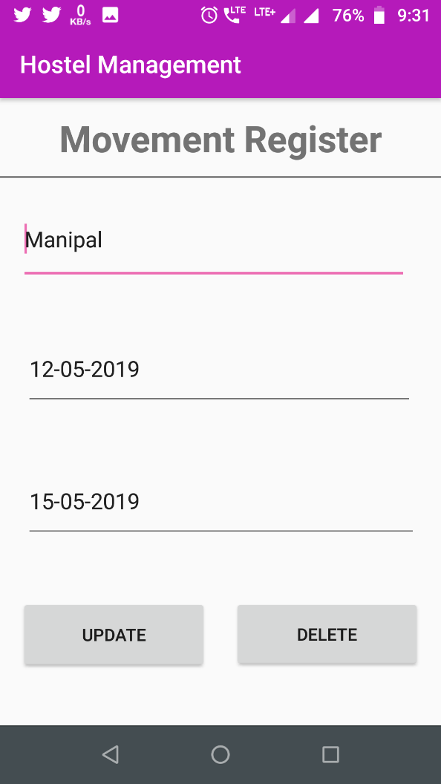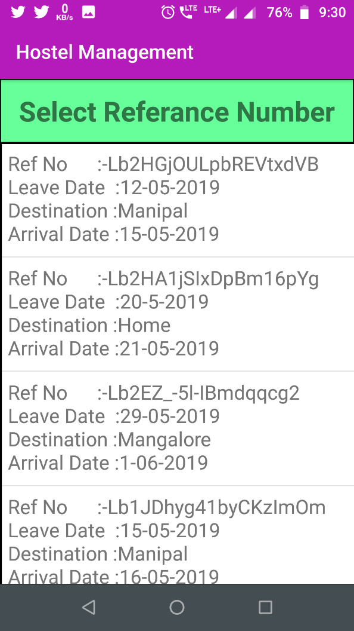

**VIII. Maintenance Register**

**i. Add or delete Options ii. Add register form**

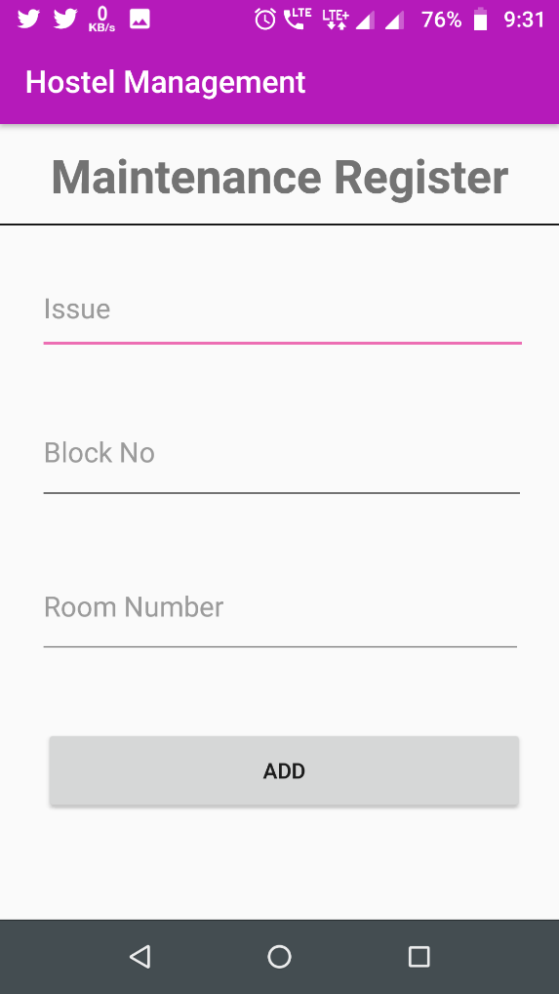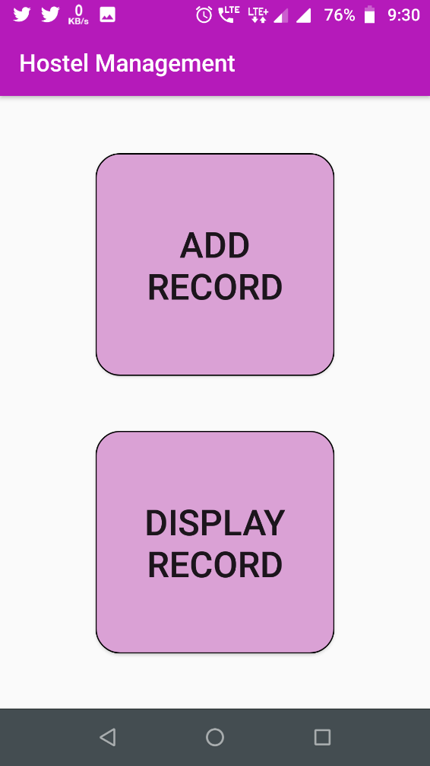

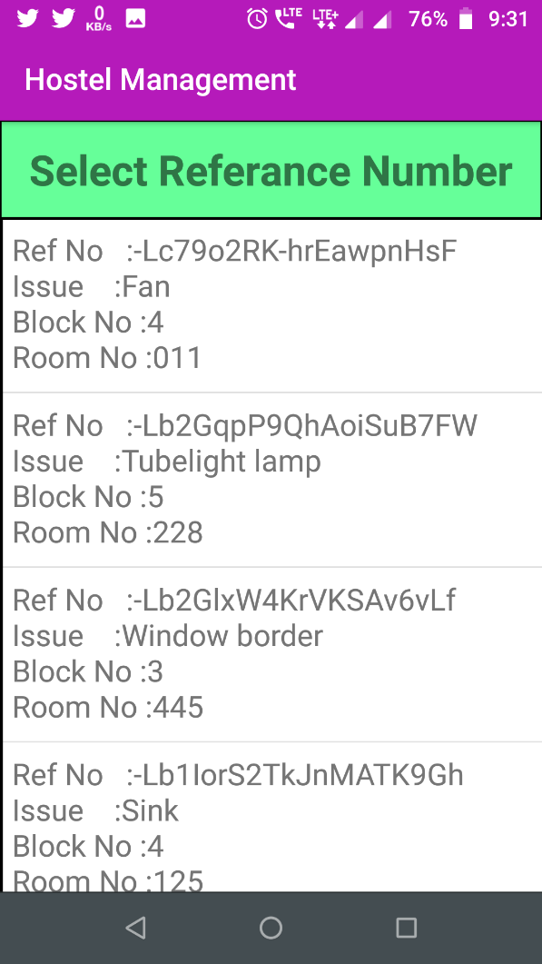**iii. List of registers added iv. Update form with a delete button**

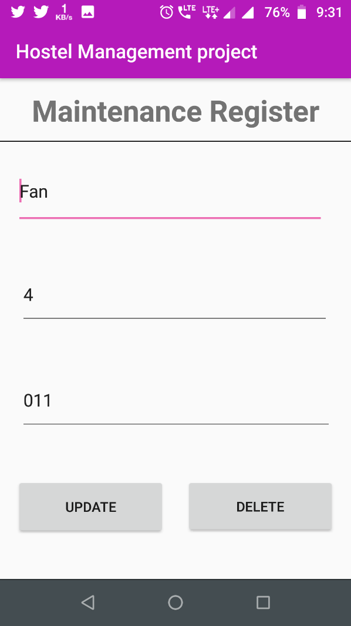

**IX.Contact Info(on clicking on any view loads call intent)**

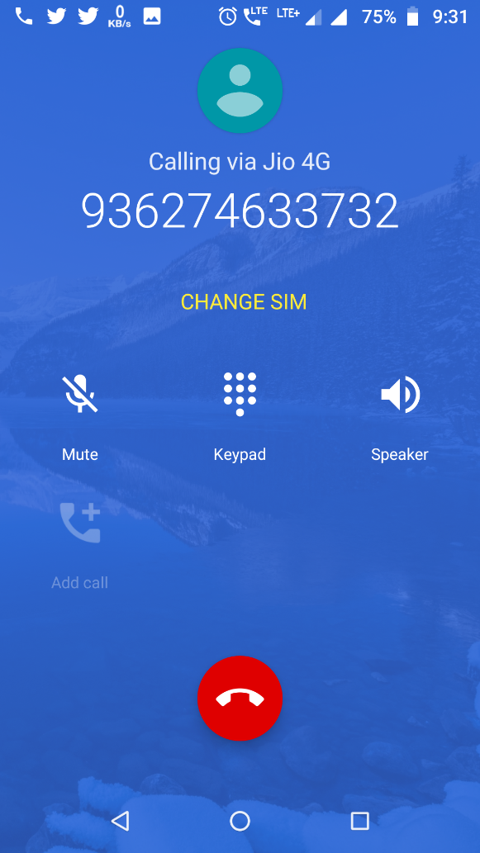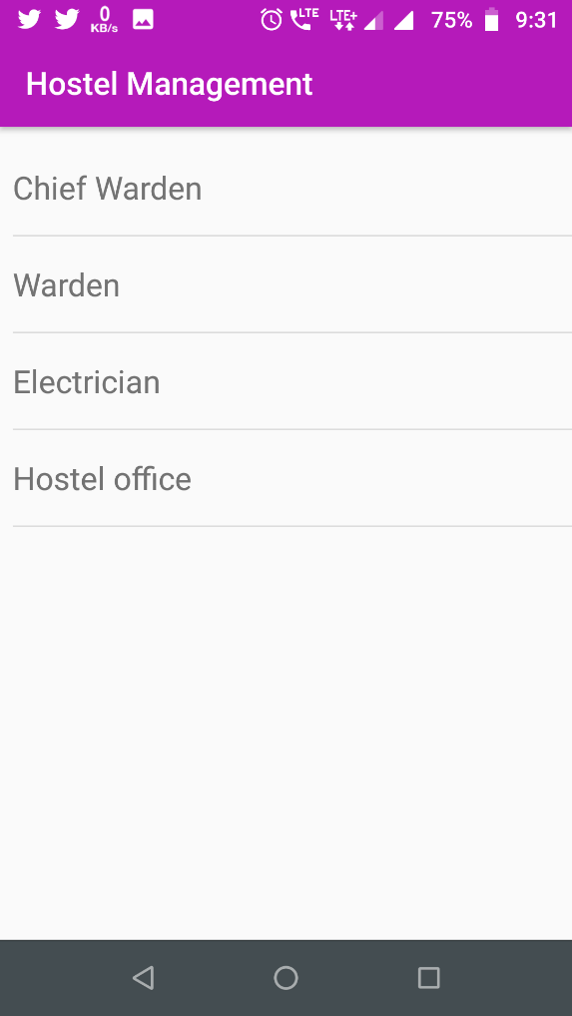

**X. Developer Bio**

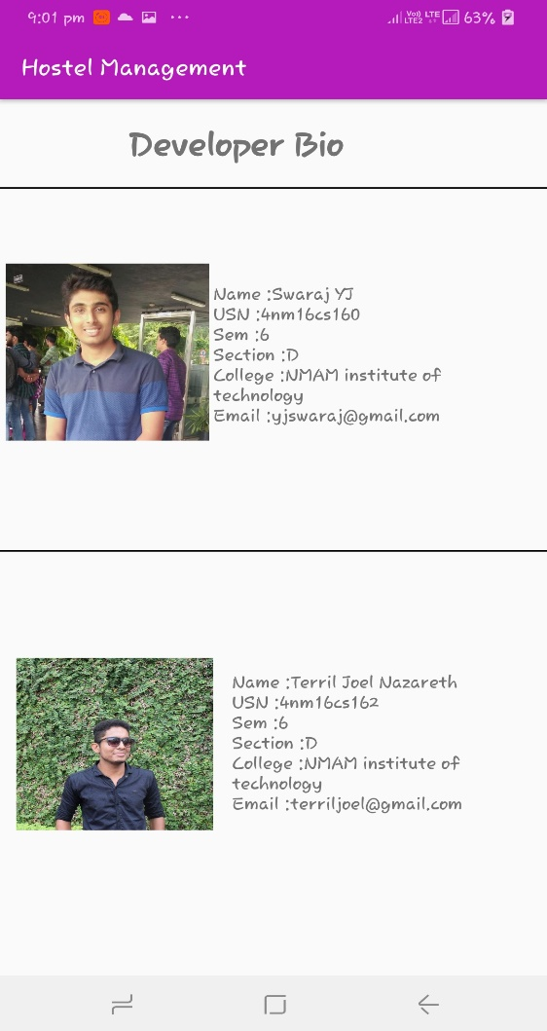

**CHAPTER 8**

**CONCLUSION AND FUTURE WORK**

**8.1 Results/conclusion:**

* Hostel Management app is an android application used to manage the activities of the hostel.
* Movement register is used to keep track of student when they go out from the hostel.
* Maintenance register used to record any damage done to the utilities of the hostels.
* Circulars are used to send important notices to the students leaving in the hostel.
* Mess time gives the update menu of the dishes served in the hostel
* It also has contact information of the in-charge of the hostel.

**8.2 Future Works**

This mobile can be further developed by adding more features like GPS enabled student locator, Notifications etc. For now back end i.e., firebase is managed manually using firebase console which can improved by developing web page for the administrator.

**8.3 References**

* <https://howtofirebase.com/what-is-firebase-fcb8614ba442>
* <https://stackoverflow.com/>
* <https://www.geeksforgeeks.org/>